Questions and Exercises to work out and turn in:

Grading Guidelines:

* A right answer will get full credit when:

1. It is right (worth 25%)
2. It is right **AND** neatly presented making it easy and pleasant to read. (worth an **extra** 15%)
3. There is an **obvious and clear link** between 1) the information provided in the exercise and in class and 2) the final answer. A clear link is built by properly writing, justifying, and documenting an answer (worth an **extra** 60%).
4. Calculation mistakes will be minimally penalized (2 to 5% of full credit) while errors on units will be more heavily penalized.

You are welcome/encouraged to discuss exercises with other students or the instructor. But, ultimately, **personal** writing is expected.

* USE THIS FILE AS THE STARTING DOCUMENT YOU WILL TURN IN. **DO NOT DELETE ANYTHING FROM THIS FILE:** JUST **INSERT** EACH ANSWER **RIGHT AFTER ITS QUESTION/PROMPT**.
* IF USING HAND WRITING (STRONGLY DISCOURAGED), **USE THIS FILE** BY CREATING SUFFICIENT SPACE AND WRITE IN YOUR ANSWERS.
* FAILING TO FOLLOW TURN IN DIRECTIONS /GUIDELINES WILL COST **A 30% PENALTY.**

**Objectives of this assignment**:

* to use and manipulate the concepts presented in this module
* to propose and write algorithms in pseudocode
* to analyze the time complexity of algorithms
* to analyze the space complexity of algorithms
* to learn autonomously new concepts

What you need to do:

Answer the questions and/or solve the exercises described below.

Exercise 1 (50 points) Kruskal’s Algorithm

Consider this graph G=(V, E, w) provided as an adjacency-matrix. V = (r, s, t, u, v, w, x, y)

|  |  |  |  |  |  |  |  |  |
| --- | --- | --- | --- | --- | --- | --- | --- | --- |
|  | r | s | t | u | v | w | x | y |
| r |  | 13 | 17 |  |  |  |  |  |
| s | 13 |  |  | 16 |  |  |  |  |
| t | 17 |  |  | 19 |  |  |  |  |
| u |  | 16 | 19 |  | 21 | 26 |  |  |
| v |  |  |  | 21 |  | 17 | 13 |  |
| w |  |  |  | 26 | 17 |  | 17 |  |
| x |  |  |  |  | 13 | 17 |  |  |
| y |  |  |  |  |  |  |  |  |

1. (5 points) Draw this graph. If needed, you can draw by hand, take a picture and insert it. Just make sure the drawing is neat and pleasant (neatness is worth 15%)
2. (45 points) Trace **Kruskal’s** algorithm and **show step by the step** the construction of the minimum spanning tree. **Draw** the MST each time you add an edge. **Highlight** the latest added edge with its weight.

We start with a set of edges A, building by adding one edge at a time. We set A to an empty set. After that we create small sets of the vertices of the graph. We will then take all edges of G and sort them in non-decreasing order. For each edge, we look at the endpoint of the edges. If they belong to different sets, we will add that edge to A and we will make a union of the two sets to which u and v belong.

Edges: non-decreasing order:

(x, y) 7

(r, y) 9

(r, s)13

(v, x) 13

(s, u) 16

(r, t) 17

(v, w) 17

(w, x) 17

(t, u) 19

(u, v) 21

(u, w) 26

Graph G The first edge in non-decreasing order is with weight of 7 is (x, y). We will at this edge to A and we will create a union of {x, y}. After this, look to the next smallest edge.

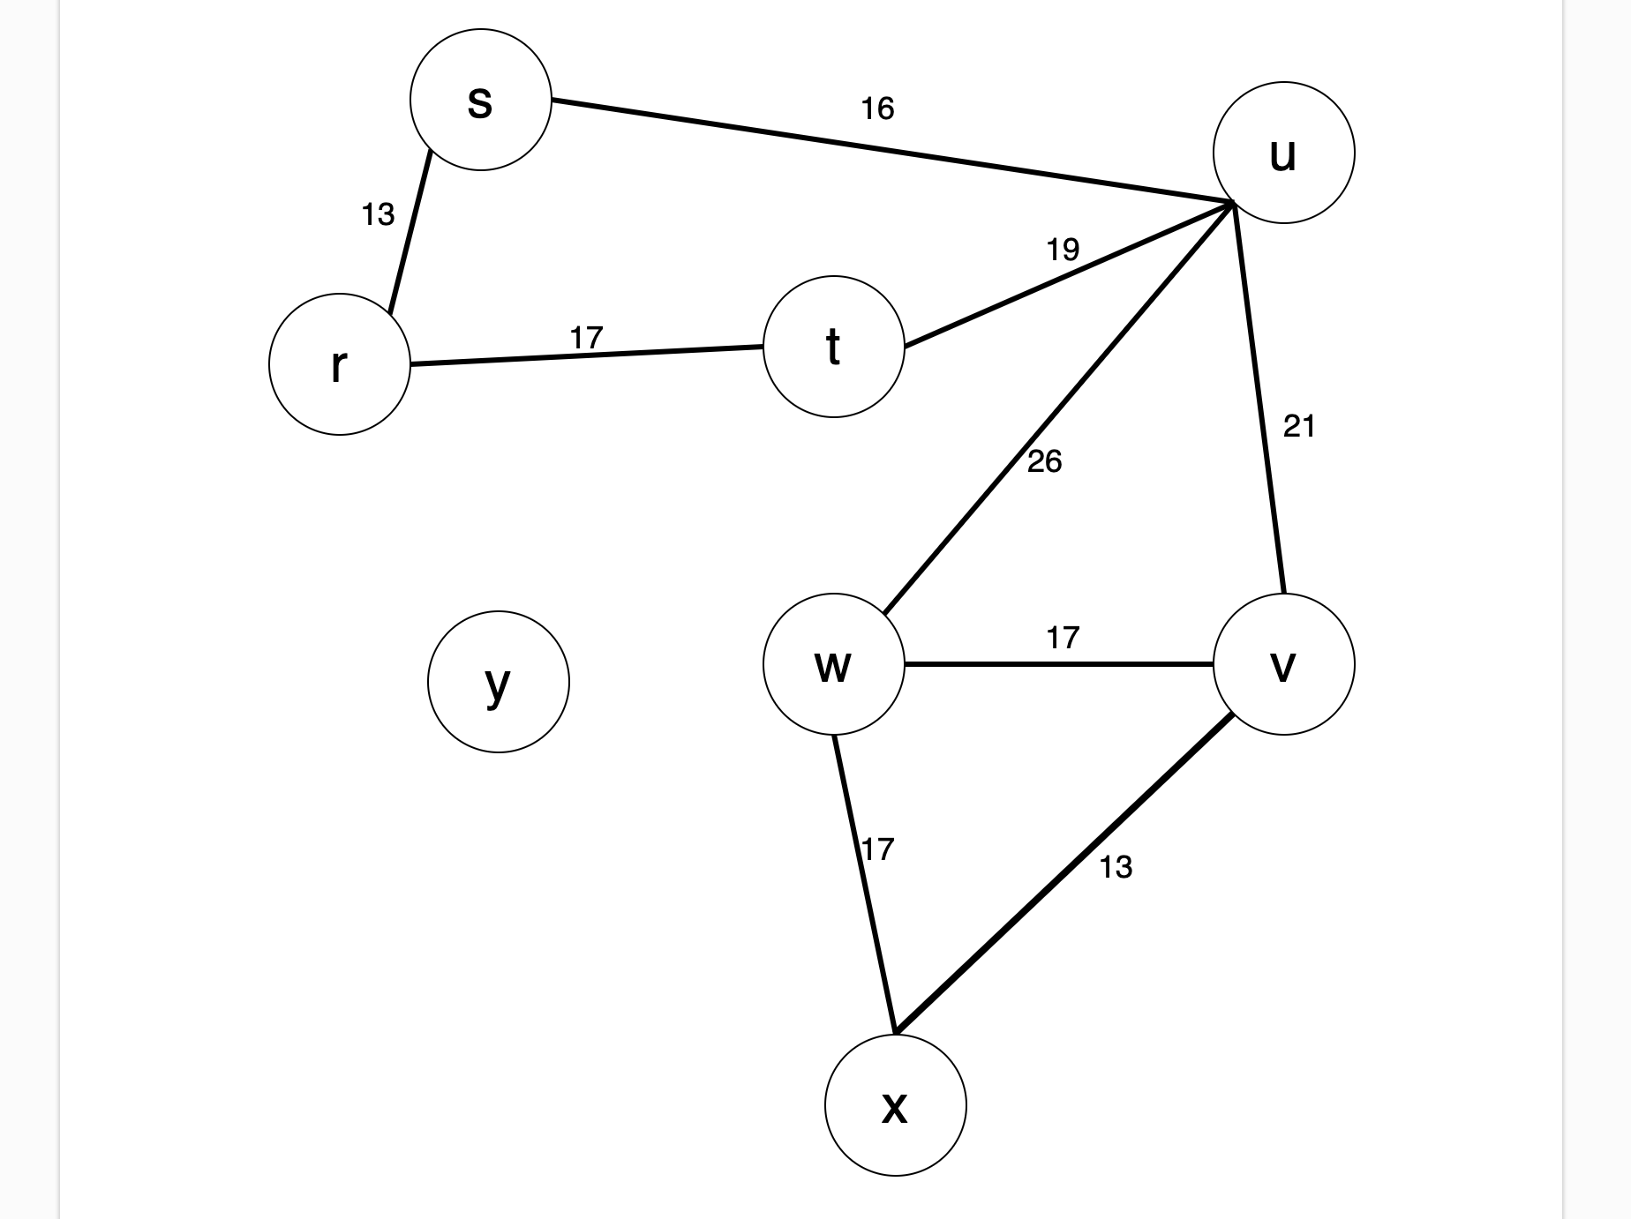

(r, y) is the next smallest edge. We look to see if (r,s) is the next smallest edge. They do not belong

r and y belong to the same set. They do not so we to the same set so we add to A and make a union.

add to A and make a union. The new set is The new set is {s, r, y x}. After this, we look to

{r, y, x}. After this, we look to the next smallest the next smallest edge.

edge.

(v, x) is the next edge. We look to see if v and x (s, u) is the next edge. We look to see if s and u

belong to the same set. They do not so we add to belong to the same set. They do not so we add to

A and make a union. The new set is {s, r, y, x, v}. A and make a union. The new set is {u, s, r, y, x, v}

After this, we look to the next smallest edge. After this, we look to the next smallest edge.

(r, t) is the next edge. We look to see if r and t (v, w) is the next edge. We look to see if v and w

belong to the same set. They do not so we add to A belong to the same set. They do no so we add to A

and make a union. The new set is {r, t}. After this, we and make a union. The new set is {u, s, r, y, x, v, w}

look to the next smallest edge.

(w, x) is the next edge. We look to see if w and x (t, u) is the next edge. We look to see if t and u

belong to the same set. They do. The both belong belong to the same set. They do. They both belong

to set {u, s, r, y, x, v, w} therefore we leave this to the same set therefore we leave this edge out.

edge out. We then look to the next smallest edge. We then look to the next smallest edge.

(u, v) is the next edge. We look to see if u and v (u, w) is the next edge. We look to see if u and w

belong to the same set. They do. They both belong belong to the same set. They do. They both belong

to the same set therefore we leave this edge out. to the same set therefore we leave this edge out.

We then look to the next smallest edge. A is now empty we are left with the resulting graph.

Exercise 2 (50 points) Prim’s Algorithm

Consider this graph G=(V, E, w) provided as an adjacency-matrix. V = (r, s, t, u, v, w, x, y)

|  |  |  |  |  |  |  |  |  |
| --- | --- | --- | --- | --- | --- | --- | --- | --- |
|  | r | s | t | u | v | w | x | y |
| r |  | 13 | 17 |  |  |  |  |  |
| s | 13 |  |  | 16 |  |  |  |  |
| t | 17 |  |  | 19 |  |  |  |  |
| u |  | 16 | 19 |  | 21 | 26 |  |  |
| v |  |  |  | 21 |  | 17 | 13 |  |
| w |  |  |  | 26 | 17 |  | 17 |  |
| x |  |  |  |  | 13 | 17 |  |  |
| y |  |  |  |  |  |  |  |  |

1. Draw this graph (It is the same as the previous question. Copy/Paste would be just fine).
2. (45 points) Trace **Prim’s** algorithm starting from Vertex and **show step by the step** the construction of the minimum spanning tree. **Draw** the MST each time you add an edge. **Highlight** the latest added edge with each weight.
3. (5 points) **Compare** the minimum spanning trees obtained by Kruskal’s and Prim’s algorithms, respectively.

The resulting minimum spanning trees obtained by Kruskal’s and Prim’s algorithms are both the same despite the different approach. Prim’s algorithm approaches it by starting from a specified vertex, Vertex u, and extends the tree by adding the cheapest outgoing edge. Whereas Kruskal’s algorithm sorts by the weight in non-decreasing order and then adds the cheapest edge that joins disjoint components. They both accomplishes the goal of providing a solution that results in the minimum weight connection between the vertices.

**What you need to turn in:**

* Electronic copy of this file (including your answers) (standalone). Submit the file as a Microsoft Word or PDF file.
* Recall that answers must be well written, documented, justified, and presented to get full credit.
* How this assignment will be graded:
* A right answer will get full credit when:
* It is right (worth 25%)
* It is right AND neatly presented making it easy and pleasant to read. (worth 15%)
* There is an obvious and clear link between 1) the information provided in the exercise and in class and 2) the final answer. A clear link is built by properly writing, justifying, and documenting an answer (worth 60%).
* Calculation mistakes will be minimally penalized (2 to 5% of full credit) while errors on units will be more heavily penalized.
* You are welcome/encouraged to discuss exercises with other students or the instructor. But, ultimately, personal writing is expected.

**Appendix**: Grading: What is an OBVIOUS and CLEAR LINK?

Here is an example to explain what an **obvious and clear link** is and how we grade your work.

Consider the following problem:

"(100 points) John travels from Auburn to Atlanta in his car at a speed of 60 mph. Leaving at 8am, at what time will John reach Atlanta".

Here are the answers of three students and their scores:

* **Student 1** answers: "9:48am". Student 1 will get 25 points.
* **Student 2**answers : "John will reach Atlanta at 9:48am". Student 2 will get 25+15 = 40 points
* **Student 3** answers: "The time t to travel a distance d at speed v is equal to d/v = d/60mph. The problem does not provide the distance d from Auburn to Atlanta. Based on GoogleMaps, the distance from Auburn to Atlanta is approximately 108 miles (**document is attached**).

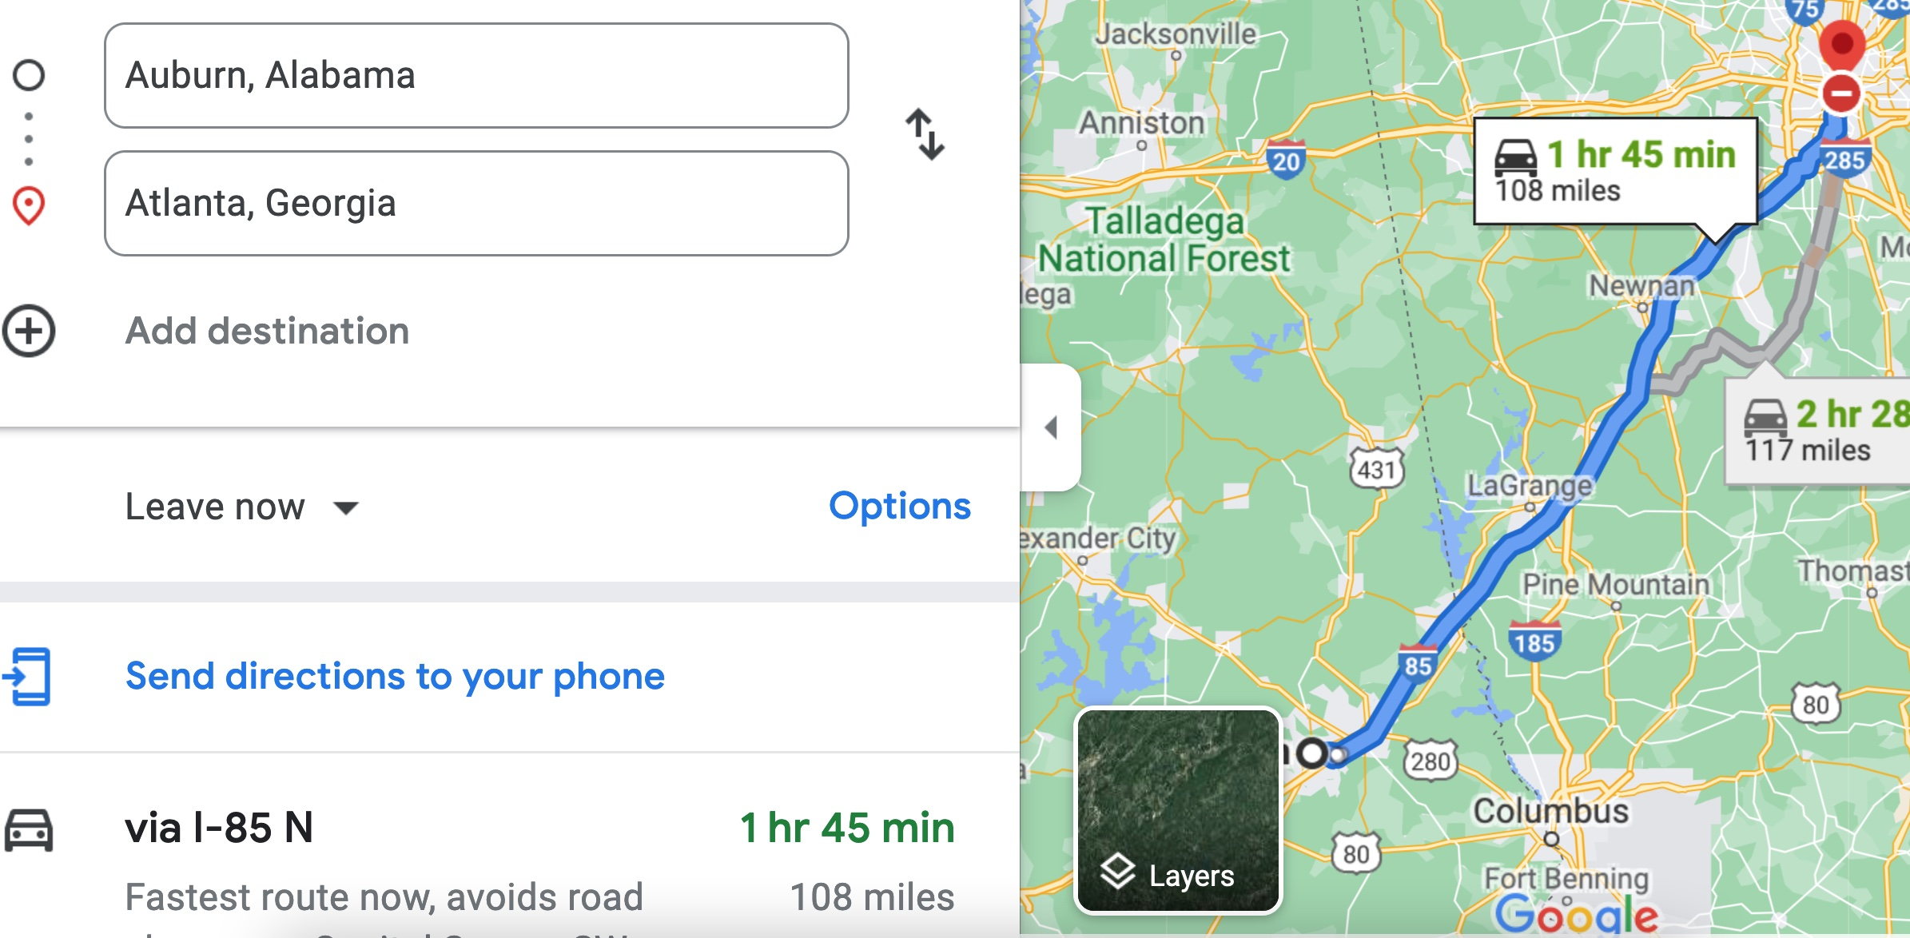

Therefore, the time t = 108 miles/60mph * 60 minutes/hour= 108 minutes. Since John left at 8am, he will then reach Atlanta at 8am + 108 minutes = 8 am + 60 minutes + 48 minutes = 9:48".

**Student 3** will get 25 + 15 + 60 = 100 points

Do you see the **direct** **link** going from the data provided in the question to the final answer, using general knowledge/formula and documents?.... Can you now solve the following problem and get 100 points?

"(100 points) Alice travels from Auburn to Atlanta in her car at a speed of 60 mph. Leaving at 8am, at what time will Alice reach Atlanta assuming that she had a flat tire that delayed her 30 minutes".